PROJECT LINK

|

|

|

|

V

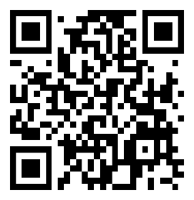

<https://www.figma.com/proto/o96WaqJWPmMjFDPeGELrK1/Weather-forcaster-app?node-id=71-310&node-type=canvas&t=VyY8GFHFul3UXWA7-1&scaling=scale-down&content-scaling=fixed&page-id=0%3A1&starting-point-node-id=71%3A310>